Merge 2 sorted listed list
Flatten a multi-level linked liste

Microservice:
Evolutionalry design
small codebase
easy to deply
easy to scale

Individually separate deplyble unit
easy to deply easy to debug the bug in flow and fixing the issue
scalling each app individualy
API Gateway (reverse Proxy): Single point of entry, Single login for all the apps
API Gateway: valdations for each request and analytics data can be captured here.
Diff module can communicate with each other using queues ex: activeMq. Async communication

Asynch Communication: allows loose coupling of the elements in distributed environment

Queue based mechanism : Point to point comm
Topic based mech : Publisher and subscriber model. One sender sending on topic and multiple listener

JSM client and provide

Publisher and subscriber both are JMS client
Provider: activeMq, works as intermediate bw publisher and subcriber

JMS connection Factory:

Fault tolerance:
If one service is down and we are communicating with that
Timeout issues
cascading faliure. One miroservice which is slow and it makes other services also slow becase pther apps are communicating with slow service.

Circuit breaker pattren: It used to deal with the problems like cascading faliure.

Which says dont call the other services directly, call with an interime layer called intercepter.
1. Interceptor will stop calling for some time if other service is down and let that to recover from over loading.
2. Intercepter return response immediately that the service is down

it count the fails and retry. If 3 reties dont work then it think app is down.

Tools for circuit breaker: (by netflix)
Hystrix and Resilience4j

Hystrix: old with single feature which is circuit breaker
Resilience4j: new and advanced features. Ex: circuit breaker
rate limiter
Retry
bulkhead

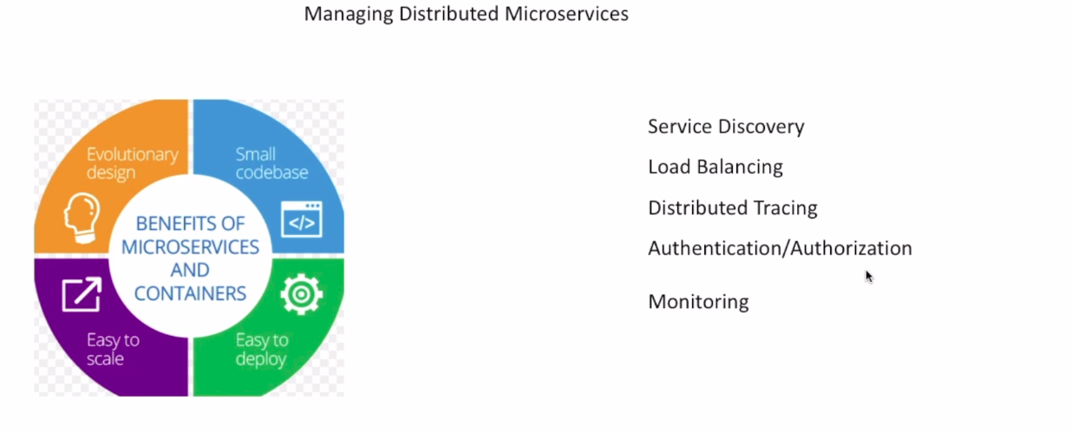
How one MS know the ip of different machine ip? : we use service discovery

Load balancing is to balance the load within apps

Dist Tracing: Use trace id. Ex: flow is in connector, flow then go to comsumer then playlist. For that we use unique trace id which can help to identify the flow from logs.

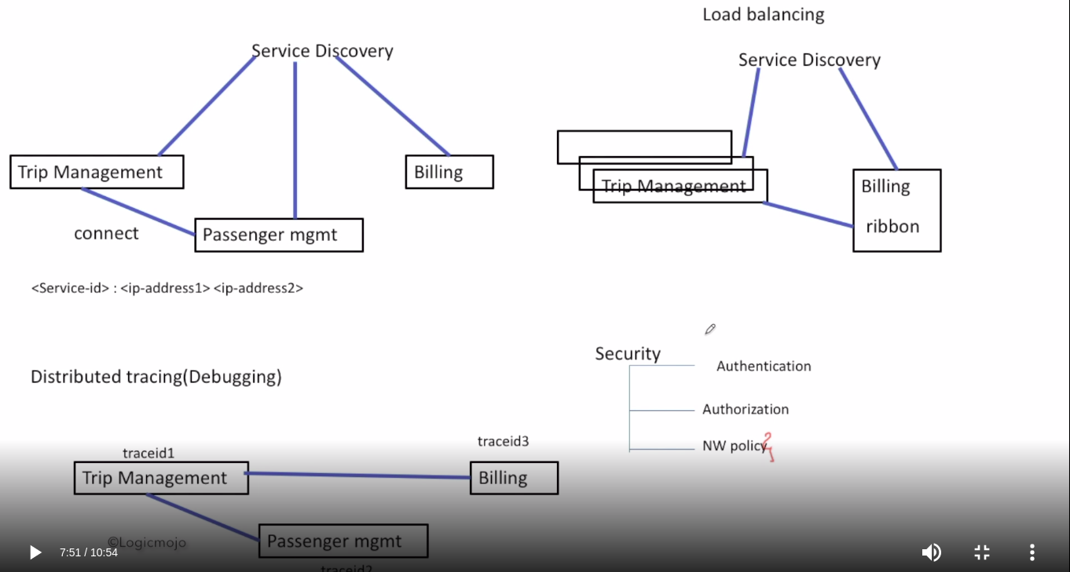
So for all these things we use Side cars and control panel
Side car: Envoy
Control Panel : Istio
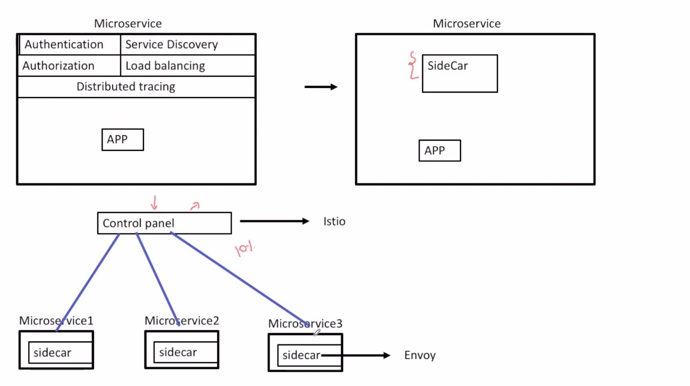

Transaction:
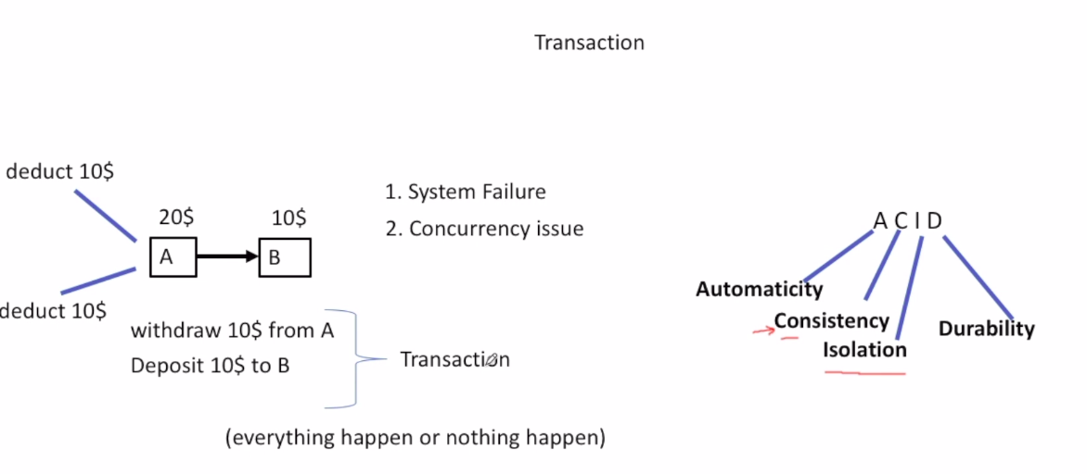
Need of Distributed Transaction:
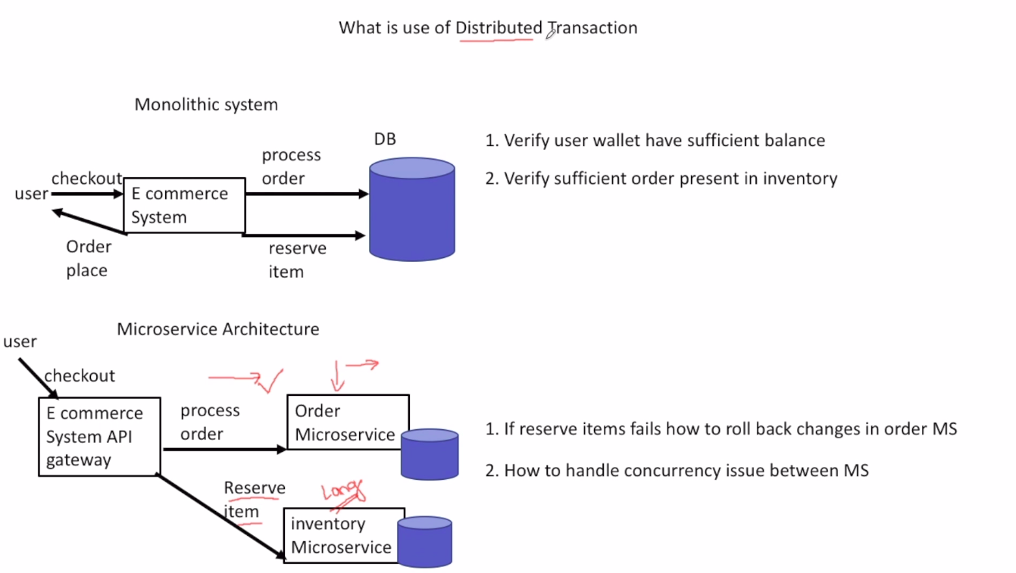
Solving Transaction issues:
1. 2 phase commit
2. Saga

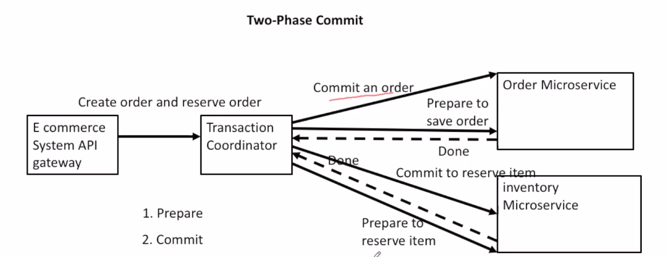
Disadvantage of 2 phase commit:
It is very slow and lock the records. It increase the latesncy as they are synchronous in nature. Transaction coordinator first lock the record and wait for another service to return success the it commit. It’s synchronization in nature so very slow.
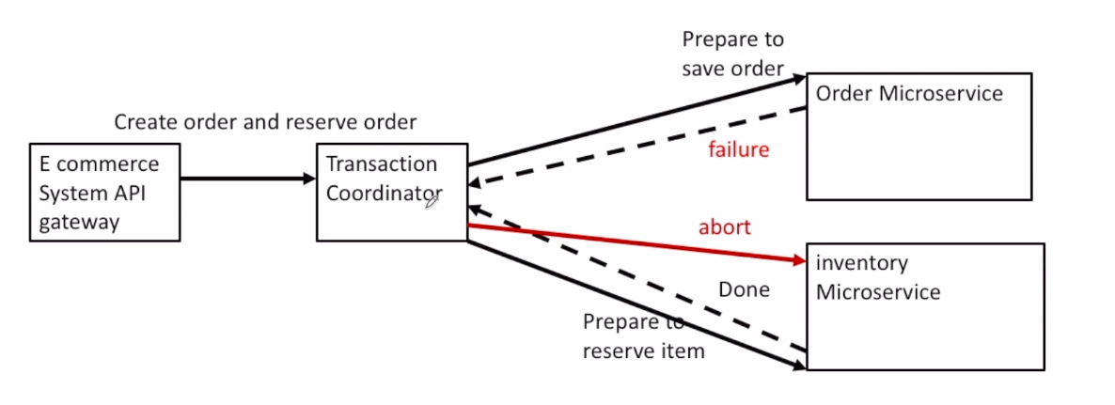

2. SAGA model:
Based on queue for making it asynch.
Sending msg to queue then listener app create new msg on success for another applications.

Advantages: Each app focus on it own bssiness logic.
No timeout because of another service
No deadlock
Makes system highly scalable
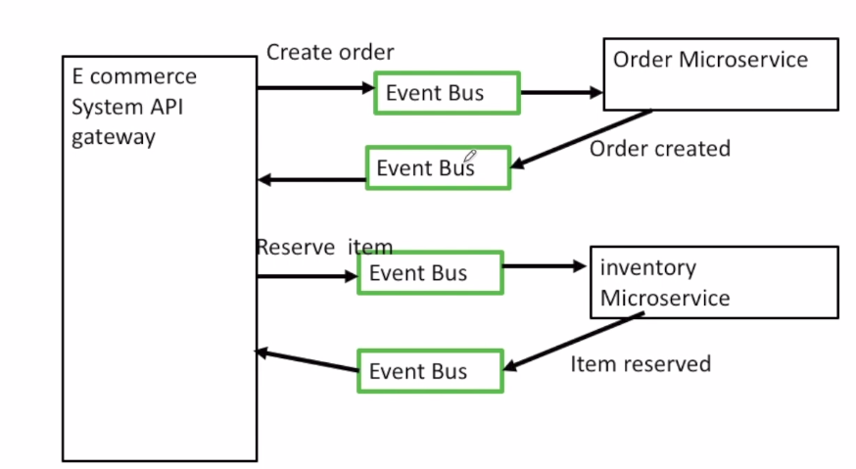

Docker

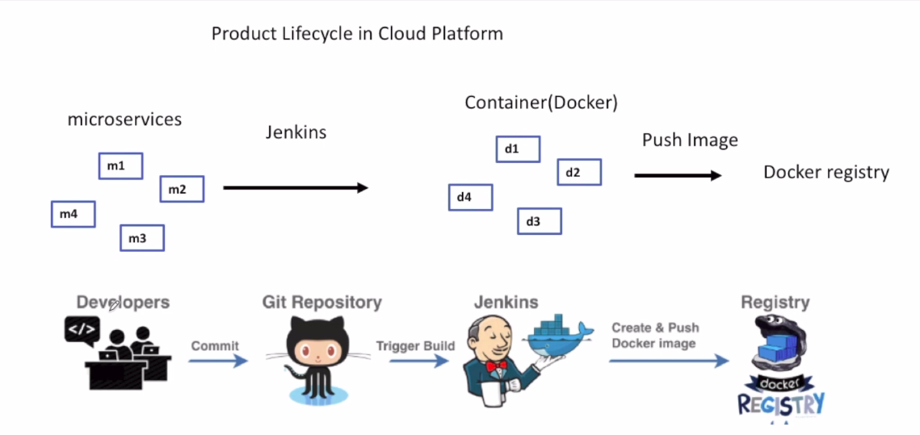
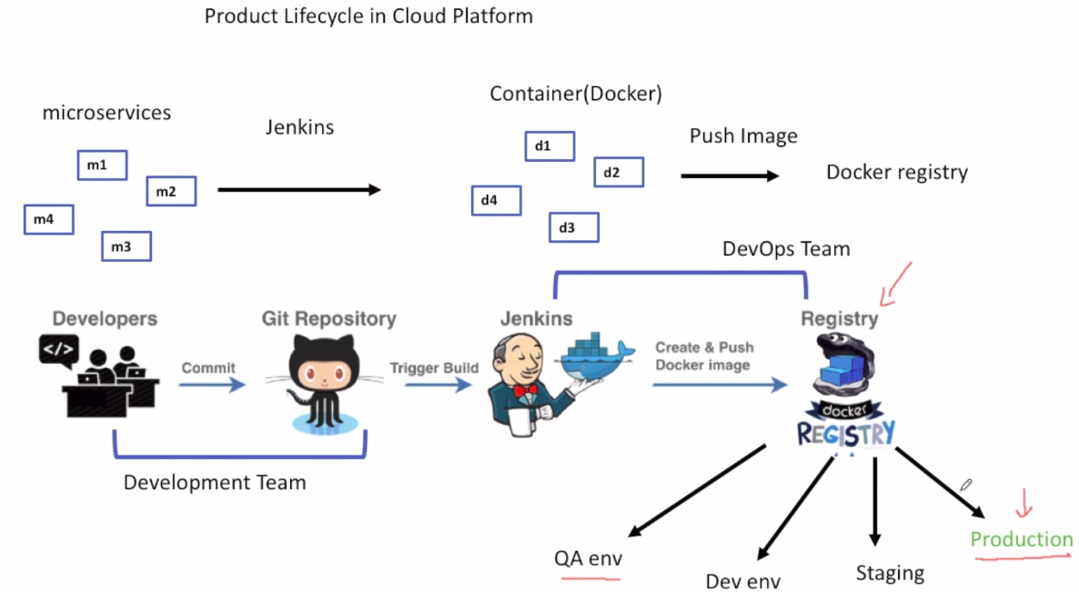

docker build
docker run
create a docker image
push docker image to docker registory (docker hub)

container flow:
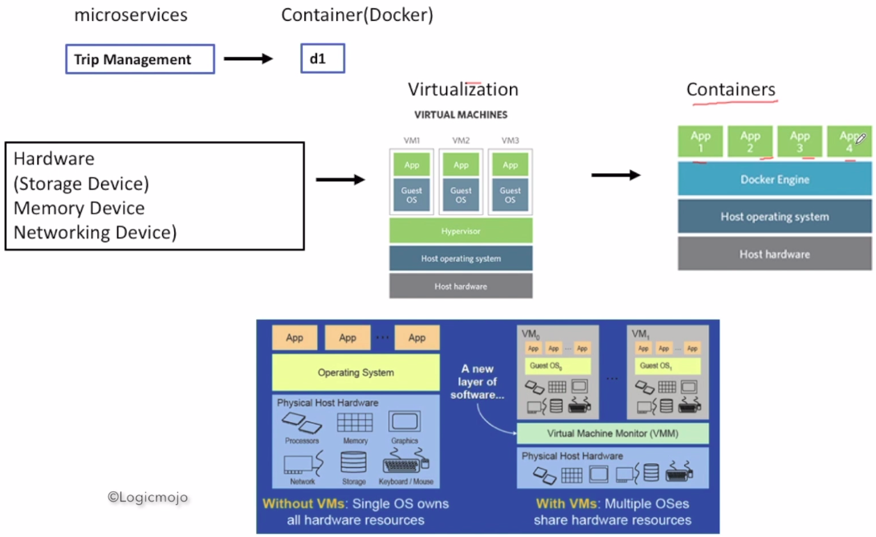

Steps to create deploy on docker:

1. install docker
2. create jar of application
3. make docker file using that jar
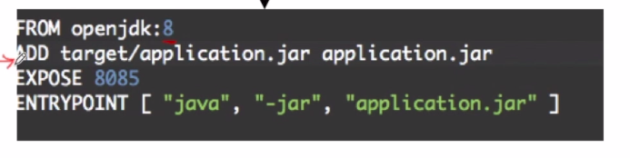
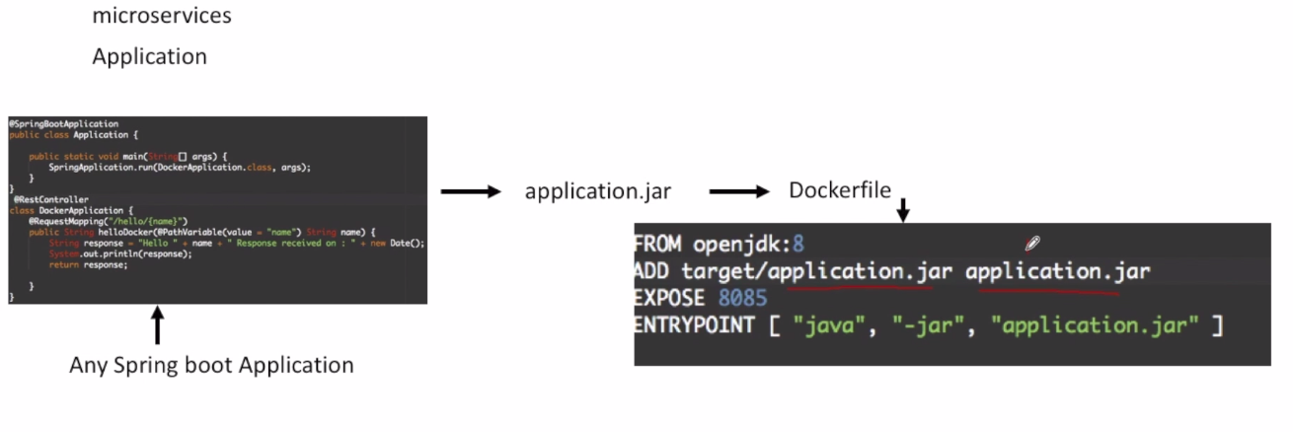
entrypoint tell how to run that jar by which command

4. build the docker image:
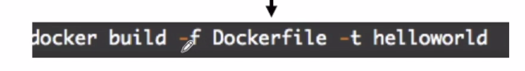
docker build -f (location of dockerfile) dockerFile -t (name of image) helloAppImageNmae

5. Verify the image is runningor not:
docker image
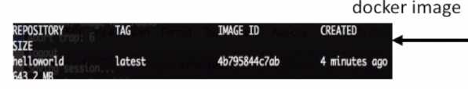
6. run the image:
docker run
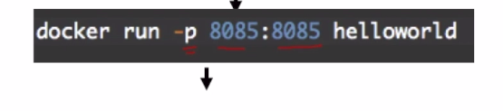
-p specify the port.
First port is exposed to users and next port is for docker app
next is appName

7. verfy the application by hitting it’s api:

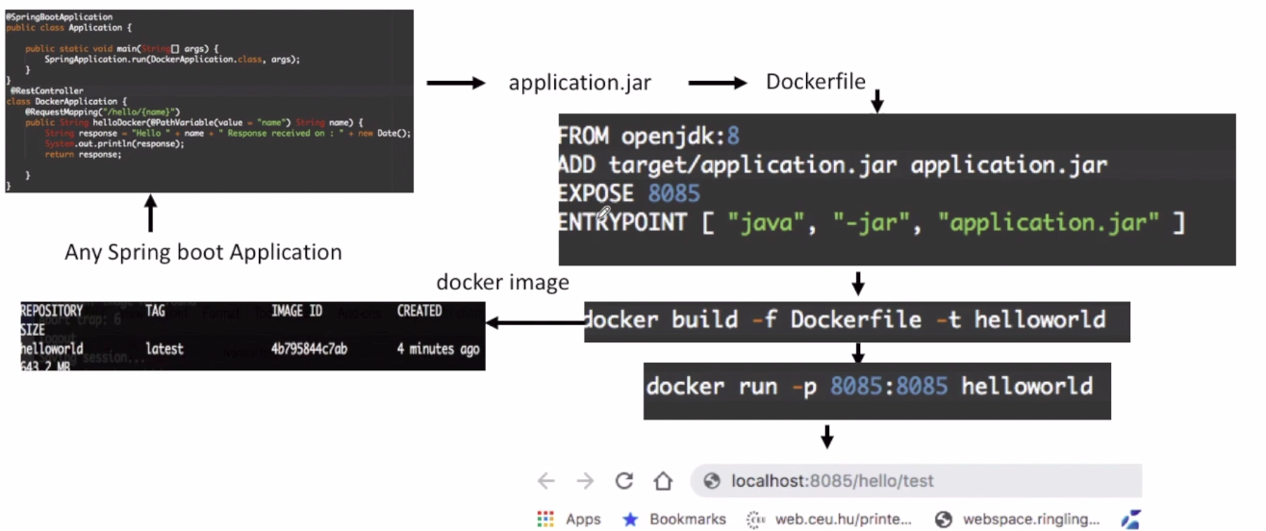
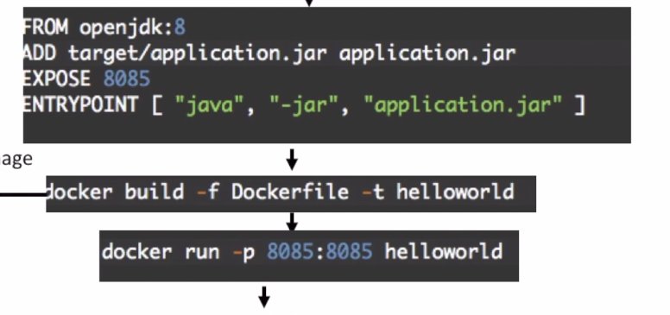
8. Push the imahe to docker hub:
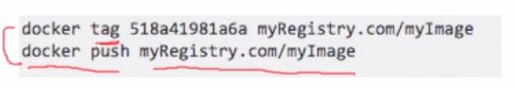
9. Now by Jenkins we pull the image on server by command docker pull.
And run the docker image in server.

